R command:
hierarchia: 1. death days_death
2. HF hosp days_hf
3. LVESV 15% változás – responder 0/1
4. BNP_change_5 – 0/1

ahol LVESV és BNP hiányzó adat van azt NA-nak tekinti, maradjon- e így vagy akik életben maradtak és hiányzott adat ott 0-nak vegyük?

> library(haven)
> library(dplyr)
> library(janitor)
> library(hce)
>
> # ---- Read & clean ----
> dat_raw <- read_dta("Desktop/stata_bud.dta") # use / or \\ on Windows
> dat <- dat_raw %>% clean_names()
>
> # If you ever get per-subject follow-up (e.g., 'days_fu'), use it; else default 365.
> alive_fu <- if ("days_fu" %in% names(dat)) pmin(as.numeric(dat$days_fu), 365) else rep(365, nrow(dat))
>
> # ---- Build HCE (best -> worst) & time-aware AVAL ----
> dat_prep <- dat %>%
+ transmute(
+ USUBJID = as.character(number),
+ TRTP = as.factor(trt),
+ died = as.numeric(died2), # 1=died, 0=alive
+ hfh = as.numeric(hfh), # 1=HFH, 0=no HFH
+ resp = as.numeric(responder), # 1 better
+ bnp5 = as.numeric(bnp_change_5), # 1 better
+ days_death = as.numeric(days_death),
+ days_hf = as.numeric(days_hf)
+ ) %>%
+ mutate(
+ died = ifelse(is.na(died), 0, died),
+ hfh = ifelse(is.na(hfh), 0, hfh),
+ resp = ifelse(is.na(resp), 0, resp),
+ bnp5 = ifelse(is.na(bnp5), 0, bnp5),
+
+ # Follow-up time used for alive/no-HFH subjects
+ fu_alive = ifelse(died == 0 & hfh == 0, alive_fu, NA_real_),
+
+ # HCE category (BEST -> WORST order defined below)
+ HCE = case_when(
+ died == 1 ~ "Death",
+ hfh == 1 ~ "HFH",
+ resp == 1 & bnp5 == 1 ~ "Alive_noHFH_resp1_BNP1",
+ resp == 1 & bnp5 == 0 ~ "Alive_noHFH_resp1_BNP0",
+ resp == 0 & bnp5 == 1 ~ "Alive_noHFH_resp0_BNP1",
+ TRUE ~ "Alive_noHFH_resp0_BNP0"
+ ),
+ HCE = factor(
+ HCE,
+ levels = c(
+ "Alive_noHFH_resp1_BNP1",
+ "Alive_noHFH_resp1_BNP0",
+ "Alive_noHFH_resp0_BNP1",
+ "Alive_noHFH_resp0_BNP0",
+ "HFH",
+ "Death"
+ )
+ ),
+
+ # AVAL (higher = better): time-aware within each tier
+ # - Alive/no-HFH: larger follow-up better
+ # - HFH: later HFH better (use days_hf)
+ # - Death: later death better (use days_death)
+ AVAL = case_when(
+ HCE == "Alive_noHFH_resp1_BNP1" ~ 2400 + coalesce(fu_alive, 0),
+ HCE == "Alive_noHFH_resp1_BNP0" ~ 2300 + coalesce(fu_alive, 0),
+ HCE == "Alive_noHFH_resp0_BNP1" ~ 2200 + coalesce(fu_alive, 0),
+ HCE == "Alive_noHFH_resp0_BNP0" ~ 2100 + coalesce(fu_alive, 0),
+ HCE == "HFH" ~ 1000 + coalesce(days_hf, 0),
+ HCE == "Death" ~ 0 + coalesce(days_death, 0)
+ ),
+
+ # Optional columns (quiet some warnings)
+ AVAL0 = NA_real_,
+ PADY = case_when(
+ HCE == "Death" ~ days_death,
+ HCE == "HFH" ~ days_hf,
+ TRUE ~ coalesce(fu_alive, 365)
+ )
+ ) %>%
+ select(USUBJID, TRTP, HCE, AVAL, AVAL0, PADY)
>
> # ---- hce object & win statistics ----
> hce_obj <- as_hce(dat_prep, id = "USUBJID", trt = "TRTP", hce = "HCE", aval = "AVAL")
> wins <- calcWINS(hce_obj)
>
> # Win Ratio (two CI methods)
> wins$WR1
WR LCL1 UCL1 Pvalue1
1 2.936432 2.156028 3.999316 8.248291e-12
> wins$WR2
WR LCL2 UCL2 Pvalue2
1 2.936432 2.225008 3.875327 2.731149e-14
>
> # (Optional) other win-based stats
> wins$WO # Win odds
WO LCL UCL Pvalue
1 2.437724 1.890203 3.143841 5.77316e-15
> wins$WP # Win probability
WP LCL UCL Pvalue
1 0.7091099 0.656638 0.7615817 5.77316e-15

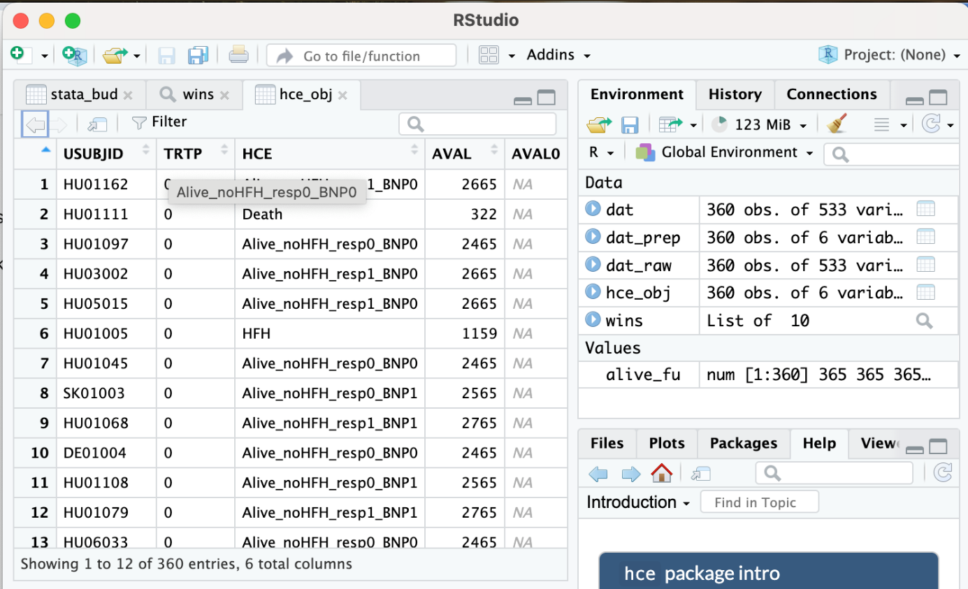

másik command sor: We don’t impute responder or BNP_change_5. If responder is missing, the code skips to BNP; if BNP is missing too, the pair is a tie.
> # Returns +1 if a beats b, -1 if b beats a, 0 if tie.
> .compare_pair <- function(a, b) {
+ # 1) Death layer (tf days_death)
+ a_died <- as.integer(a[["Died2"]]) == 1
+ b_died <- as.integer(b[["Died2"]]) == 1
+ if (a_died || b_died) {
+ if (a_died && !b_died) return(-1)
+ if (!a_died && b_died) return(+1)
+ # both died: later death is better
+ ad <- a[["days_death"]]; bd <- b[["days_death"]]
+ if (!is.na(ad) && !is.na(bd)) {
+ if (ad > bd) return(+1)
+ if (ad < bd) return(-1)
+ }
+ return(0) # same day or a/b missing -> tie
+ }
+
+ # 2) HFH layer (tf days_HF)
+ a_hf <- as.integer(a[["HFH"]]) == 1
+ b_hf <- as.integer(b[["HFH"]]) == 1
+ if (a_hf || b_hf) {
+ if (a_hf && !b_hf) return(-1)
+ if (!a_hf && b_hf) return(+1)
+ # both had HFH: later is better
+ ah <- a[["days_HF"]]; bh <- b[["days_HF"]]
+ if (!is.na(ah) && !is.na(bh)) {
+ if (ah > bh) return(+1)
+ if (ah < bh) return(-1)
+ }
+ return(0)
+ }
+
+ # 3) Symptom layer: responder first (c >), then BNP_change_5 (c >)
+ ar <- a[["responder"]]; br <- b[["responder"]]
+ if (!is.na(ar) && !is.na(br)) {
+ if (ar > br) return(+1)
+ if (ar < br) return(-1)
+ # equal responder -> fall through to BNP
+ } else {
+ # responder missing for at least one -> fall through to BNP
+ }
+
+ # 4) BNP (higher = better). Keep NA (no imputation).
+ ab <- a[["BNP_change_5"]]; bb <- b[["BNP_change_5"]]
+ if (!is.na(ab) && !is.na(bb)) {
+ if (ab > bb) return(+1)
+ if (ab < bb) return(-1)
+ }
+ return(0) # equal or missing -> tie
+ }
>
> # ----- Win statistics over all treatment–control pairs (all-vs-all) -----
> # df: your data.frame with columns:
> # Number (patient id), trt (two-level treatment), Died2, days_death, HFH, days_HF,
> # responder, BNP_change_5
> # ref: the reference/control level in df[[trt]] (e.g., 0, "0", "Placebo", "P")
> win_stats_hierarchy <- function(df, id_col = "Number", trt_col = "trt", ref) {
+ stopifnot(all(c("Died2","days_death","HFH","days_HF","responder","BNP_change_5") %in% names(df)))
+
+ trt_vec <- df[[trt_col]]
+ ctrl_idx <- which(trt_vec == ref)
+ trt_idx <- which(trt_vec != ref)
+
+ if (length(ctrl_idx) == 0 || length(trt_idx) == 0) {
+ stop("Both treatment and reference groups must be present.")
+ }
+
+ W <- L <- Ties <- 0L
+
+ # Loop over all treatment–control pairs
+ for (i in trt_idx) {
+ a <- df[i, , drop = FALSE]
+ for (j in ctrl_idx) {
+ b <- df[j, , drop = FALSE]
+ cmp <- .compare_pair(a, b)
+ if (cmp > 0) W <- W + 1L else if (cmp < 0) L <- L + 1L else Ties <- Ties + 1L
+ }
+ }
+
+ Npairs <- W + L + Ties
+ WP <- (W + 0.5 * Ties) / Npairs # Win Probability (treatment vs ref)
+ WO <- WP / (1 - WP) # Win Odds
+ WR <- if (L == 0L) Inf else W / L # Win Ratio
+ NB <- 2 * WP - 1 # Net Benefit (equivalently (W - L)/Npairs)
+
+ list(
+ counts = c(Wins = W, Losses = L, Ties = Ties, Pairs = Npairs),
+ estimates = c(WinProbability = WP, WinOdds = WO, WinRatio = WR, NetBenefit = NB)
+ )
+ }
> View(wins)

statában:

winratio Number trt, outcomes(Died2 tf days_death) outcomes(HFH tf days_HF) outcomes(responder c >) outcomes(BNP_change_5 c >)

